**Experiment No. 4**

**Aim** : To study and demonstrate Ultrasonic Sensor usage.

**Objective** : 1. To understand ultrasonic sensors.

2. To use sensors for real time applications.

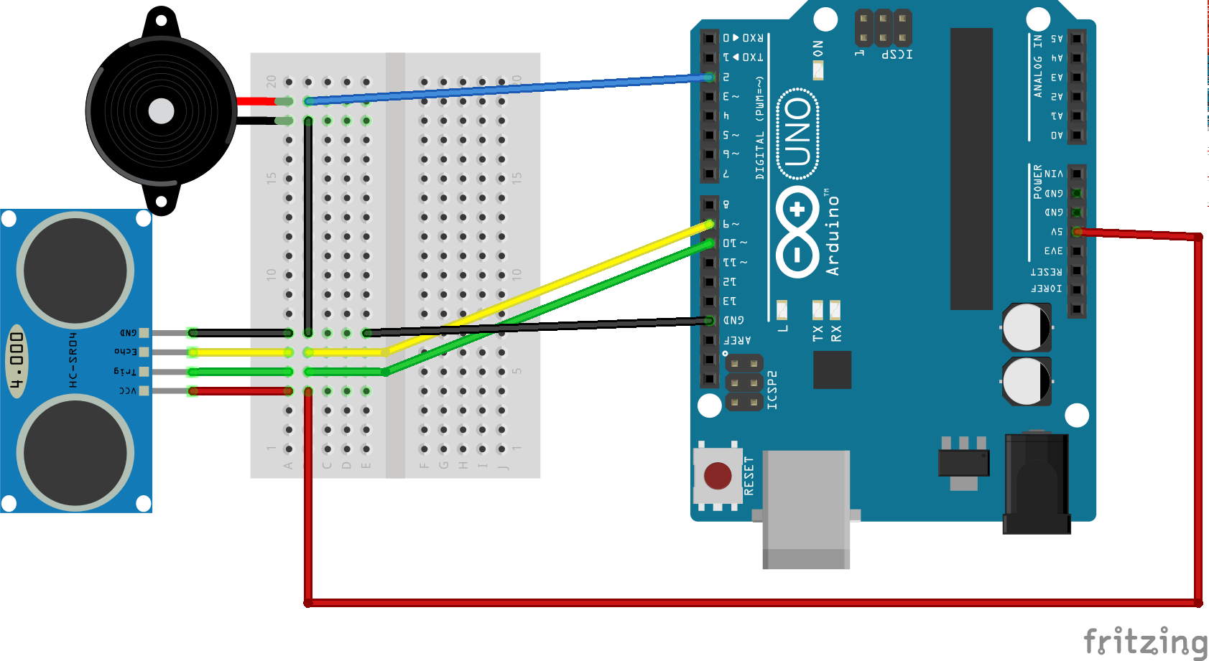

**Code :**

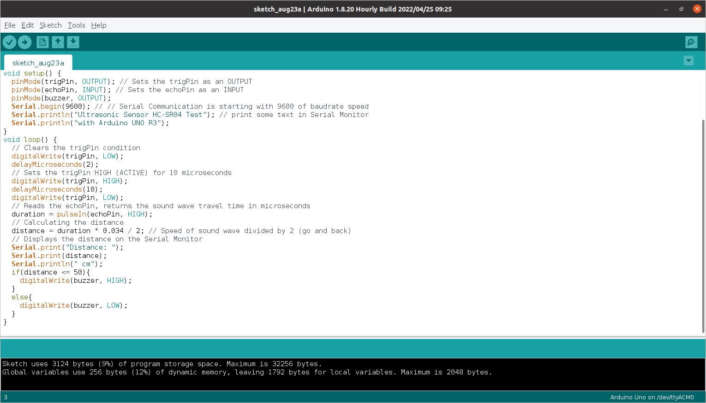



**Output :**

